**Project Title:** HAZARDOUS AREA MONITORING FOR INDUSTRIAL PLANT POWERED BY IOT **Project Design Phase-I** - **Solution Fit Template** **Team ID:** PNT2022TMID35923

**AS**

**5. AVAILABLE SOLUTIONS**

**Which solutions are available to the customers when they face the problem or need to get the job done? What have they tried in the past? What pros & cons do these solutions have? i.e. pen and paper is an alternative to digital notetaking**

Usage of MQ2 smoke sensor to reduce the combustible gas and LPG gas leakage.

**What constraints prevent your customers from taking action or limit their choices of solutions?**

Less awareness about future outcomings like survivability and health conditions, no funds, network unavailability.

**CC**

**6. CUSTOMER CONSTRAINTS**

**CS**

**1. CUSTOMER SEGMENT(S)**

**Who is your customer?**

Industrial employees working in a hazardous environment

**Explore AS, differentiate**

**Define CS, fit into CC**

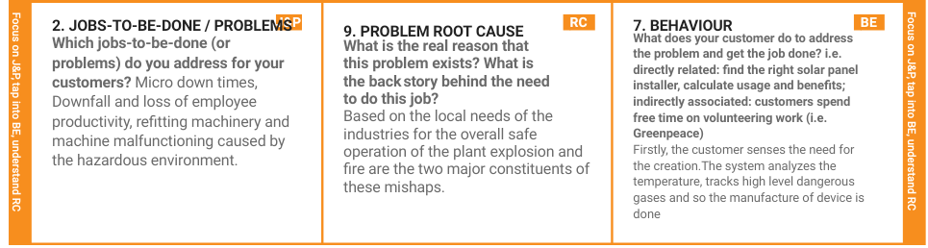



|  |  |  |  |  |
| --- | --- | --- | --- | --- |
| **Identify strong TR & EM** | **3. TRIGGERS TR**  **What triggers customers to act?**  Life assurance, Financial Loss, Machine refitting and understanding the risk rating in the work environment. | **10. YOUR SOLUTION SL**  Integration of Beacon Device as wearable scanners assisting with short message alerts. Data will be sent to the cloud and very soon will take the necessary precautions. | 1. **CHANNELS of BEHAVIOUR CH**     1. **ONLINE**   What kind of actions do customers take online? Extract online channels from #7  The scanners used by the Industrial workers help in tracking, acquiring and transmitting data(Temperature, Gas levels) to the cloud monitored by the admin.   * 1. **OFFLINE**   **What kind of actions do customers take ofﬂine? Extract ofﬂine channels from #7 and use them for customer development.**  High quality Beacons Scanners are designed for sensing hazardous levels. |  |
| **4. EMOTIONS: BEFORE / AFTER EM**  **How do customers feel when they face a problem or a job and afterwards?**  When they face a problem : Breathing, Anxiety, Peer pressure, Hesitance and Upset about job.  When a solution is found : Confidence, Safe, Delight, Security. |